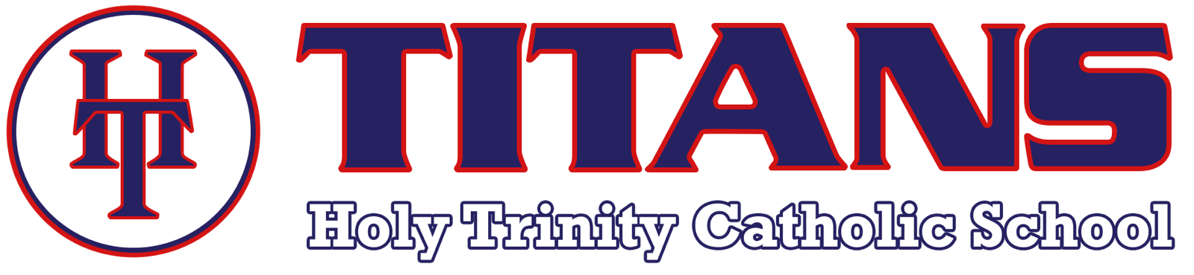
ROSETTA STONE K12 LANGUAGE SOLUTIONS
5TH-8TH GRADES
Rosetta Stone K12 Language Solutions is a student centered language learning program that suits a broad range of proficiency levels, has up to 24 languages available and offers a wide variety of rich content. Engaging lessons and activities give instant speech feedback, which guides pronunciation. Rosetta Stone teaches and supports reading, writing, speaking and listening skills. K12 provides usage progress, proficiency reporting, enhanced support services and proven implementation success.

Grades | Grading Criteria
5th  6th  7th  8th | Pass/Fail  Progress, Accuracy and Time Spent algorithm
Languages | Commitment
Arabic (3 levels)  Chinese Mandarin (5 levels)  Dutch (3 levels)  English American (5 levels)  English British (5 levels)  Filipino Tagalog (3 levels)  French (5 levels)  German (5 levels)  Greek (3 levels)  Hebrew (3 levels)  Hindi (3 levels)  Irish (3 levels)  Italian (5 levels)  Japanese (3 levels)  Korean (3 levels)  Persian Farsi (3 levels)  Polish (3 levels)  Portuguese Brazil (3 levels)  Russian (5 levels)  Spanish Latin America (5 levels)  Spanish Spain (5 levels)  Swedish (3 levels)  Turkish (3 levels)  Vietnamese (3 levels) | February 1, 2018-September 4, 2018  One chosen language  Students can use Rosetta Stone  ALL SUMMER LONG!  One language switch can be made  as school begins Fall 2018.  One chosen language for  2018-2019 school year.  2 scheduled class periods  + 30 minutes study at home per week  Students track progress on provided Rosetta Stone form.  Foreign Language Proctor tracks progress through reports pulled from Rosetta Stone database.

Frequently Asked Questions:

- Does Rosetta Stone require Internet?
  - Yes, you must have Internet access. Rosetta Stone works across all devices (iPad, iPhone, Chromebook, laptop, Android device). Your progress is automatically saved as you move across devices.

- How will progress be communicated to parents and students?
  - Students will keep a paper log of their progress as they finish each lesson and unit.
  - Foreign Language Proctor will have access to all Rosetta Stone produced reports to enter information, scores and progress into School Speak. Progress will be reported and published, as with all 5th-8th grades, every other Monday.

- What materials are needed?
  - Students need a device, Internet access and a microphone/headphone set. The microphone/headphones that come with iPhones work well. Headsets can also be purchased from a variety of retailers (Amazon, Best Buy, Target, approx. $11-20).
  - Families are asked to supply their own headsets for hygiene reasons.

- What will a Foreign Language class look like?
  - All students will have their own device, headset, log in and progress tracking sheet. Students will be expected to meet a minimum required active minutes per period as well as meet a Lesson/Unit benchmark by the end of the marking period.

- Does using Rosetta Stone support our students in high school?
  - Yes, students who successfully complete Levels 1 and 2 of Rosetta Stone can choose to take a foreign language exam at their chosen high school in order to test out of year one or more.

- What do the local high schools offer for foreign language?

St. Mary’s Academy | Jesuit | Central | Valley Catholic | Sunset High
French  Spanish | Chinese Mandarin  French  Latin  Spanish | American Sign Language  French  Japanese  Spanish | American Sign Language  French  Spanish | French  Japanese  Spanish

